Description of homework
4.2 BASIC DATA TRANSFORMATION
Description:
In the DimCustomer table, I created a Full Name column by duplicating the 'First Name' and 'Last Name' columns and merging them using a Space separator.
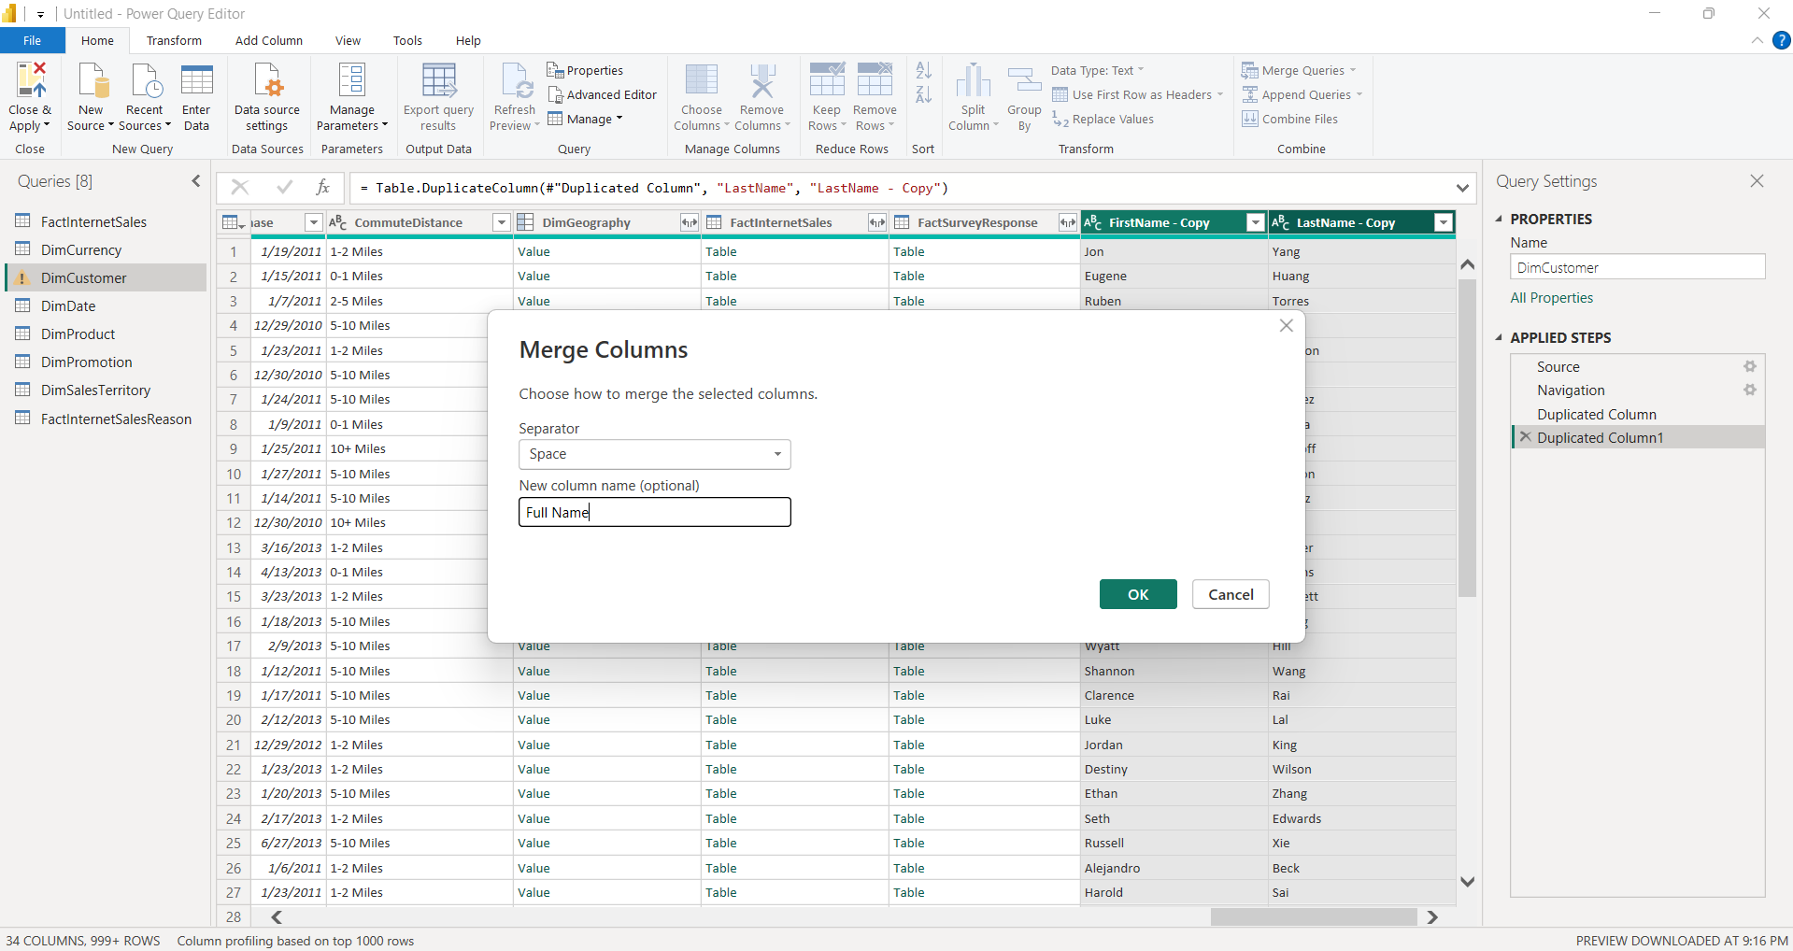

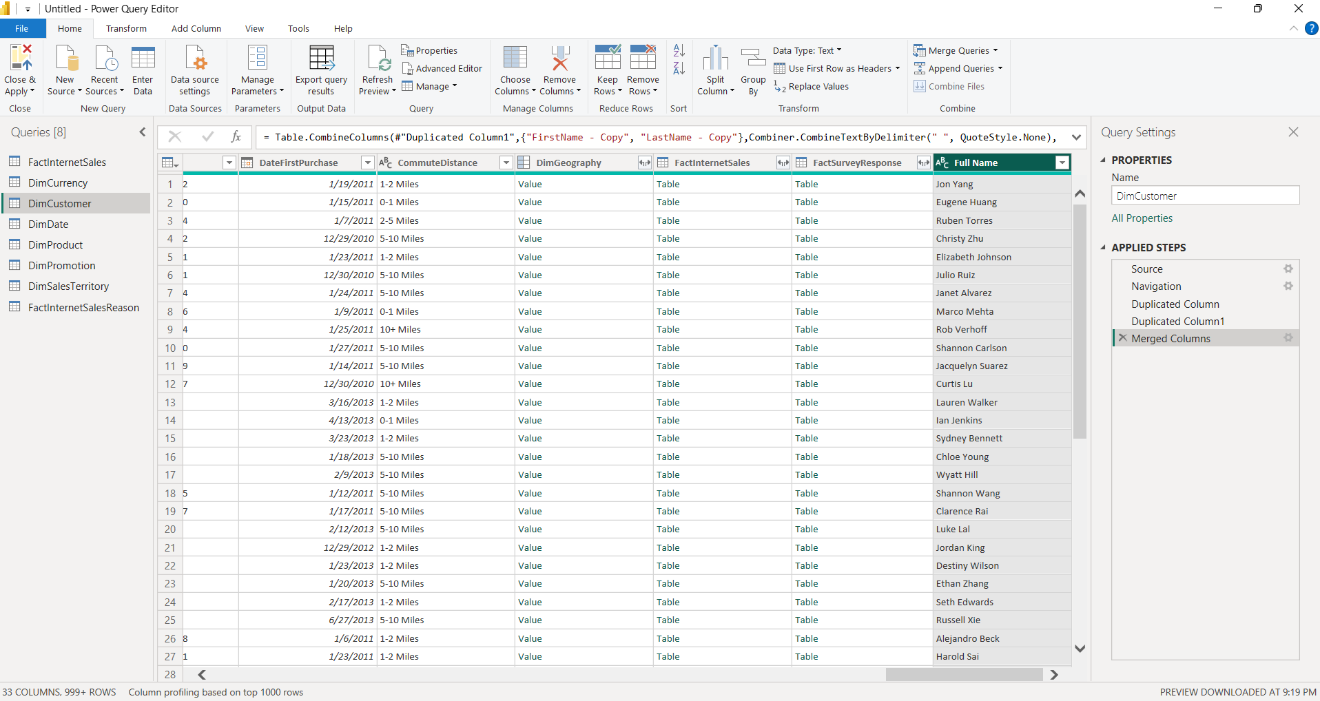

In the DimPromotion table, I updated the DiscountPct column's data type to Percentage for accurate calculation.
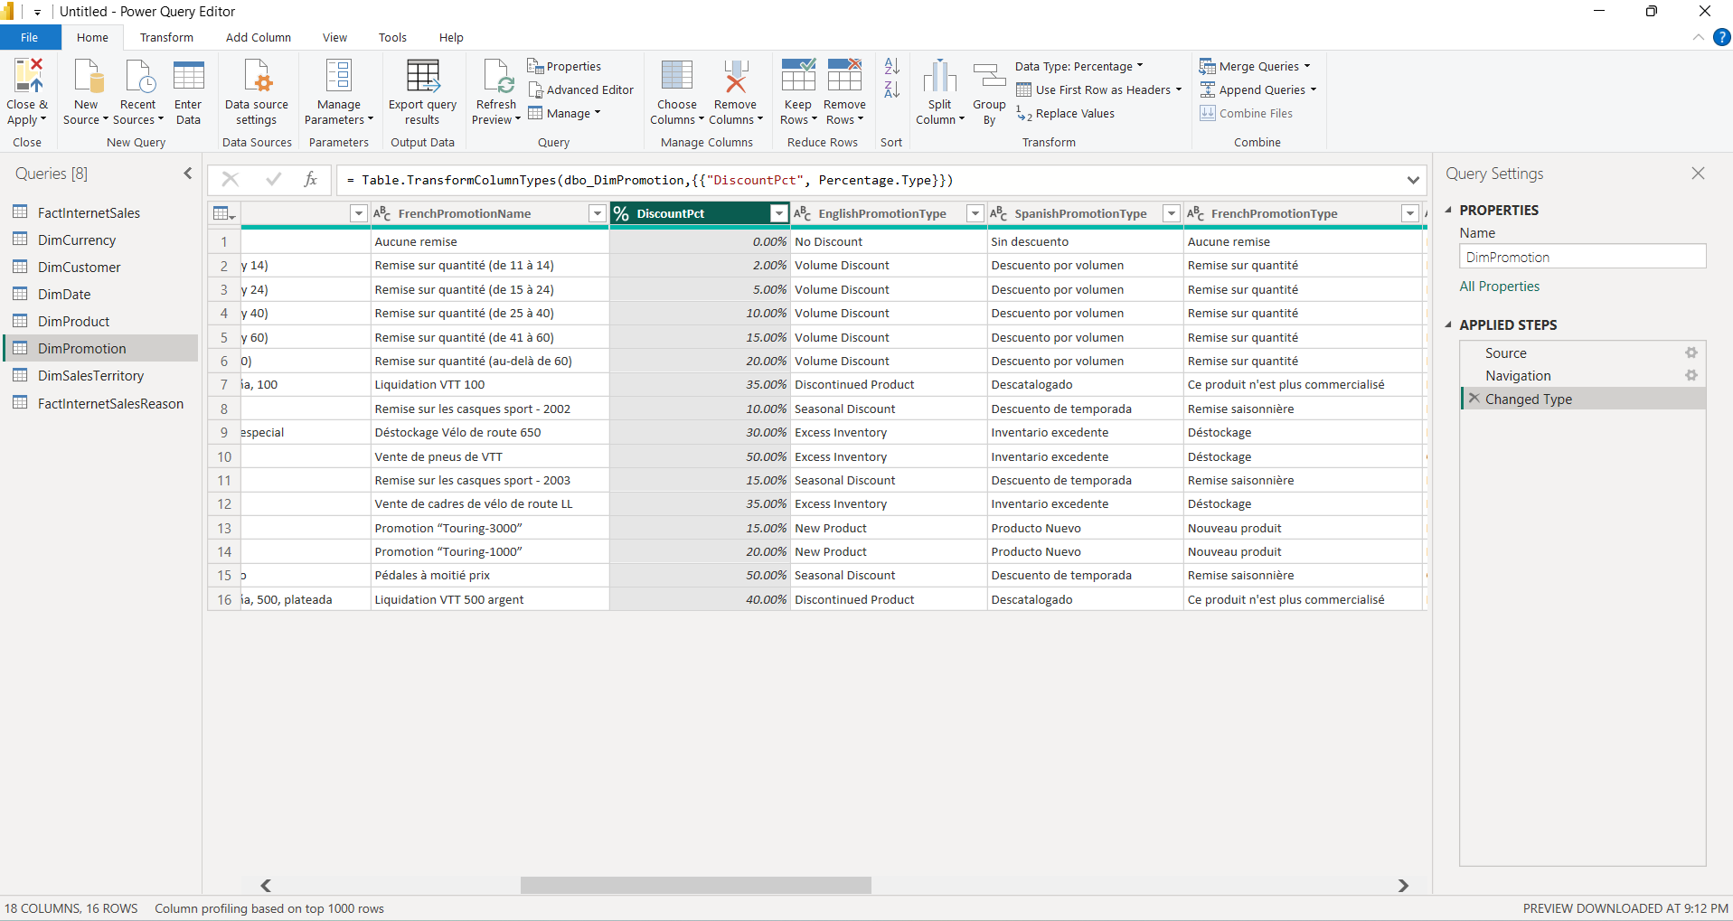

To calculate the promotion length, I added a custom column named "Promotion, days" using the formula Duration.Days([EndDate] - [StartDate])
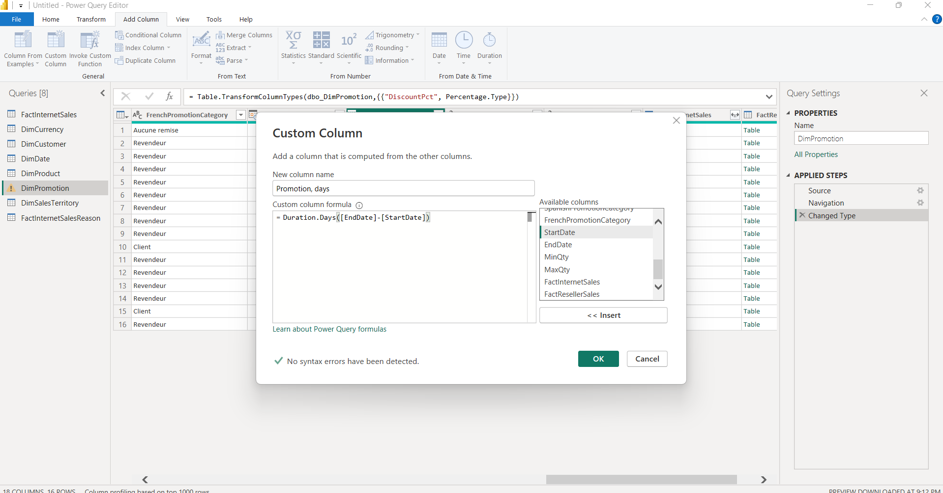

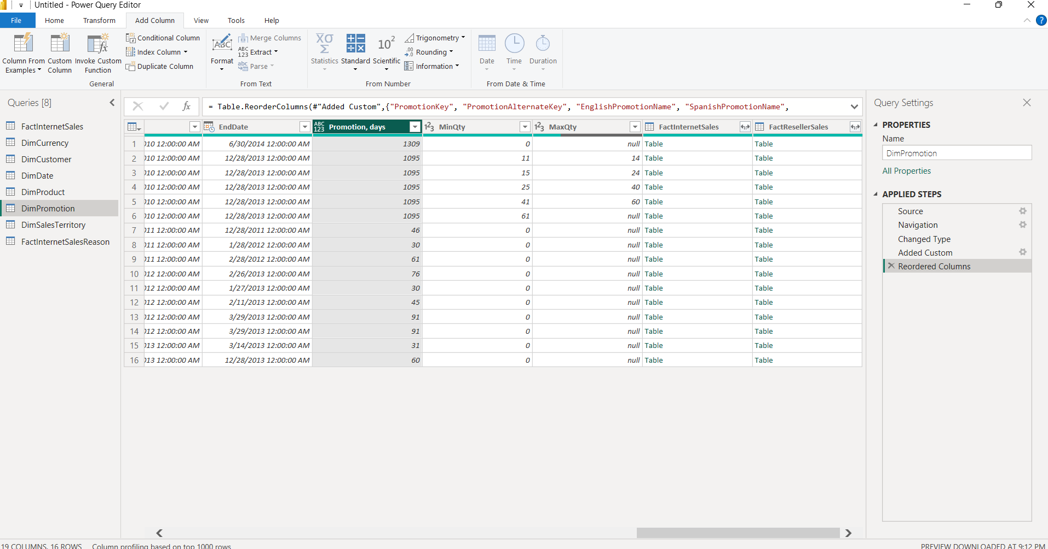

4.3 ADDING NEW TABLES, 4.4 DATA PROFILING
Description:
I expanded the data model by loading two additional tables from the AdventureWorks source: DimProductSubcategory and DimProductCategory. Using the View tab, I enabled Column Quality, Column Distribution, and Column Profile. This allows for a quick assessment of data health, identifying empty values or errors in each column.
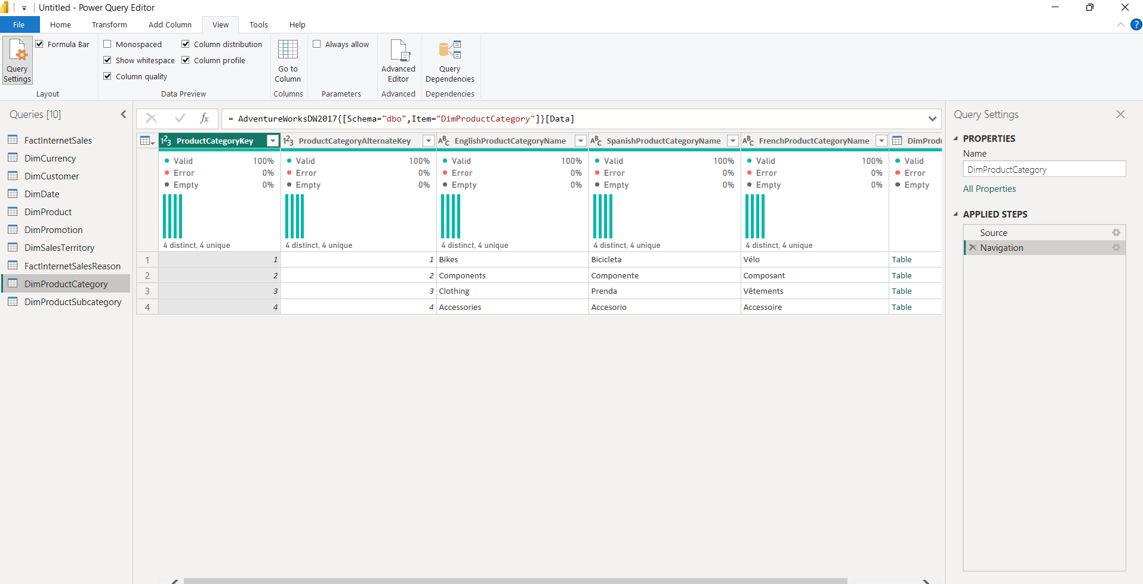

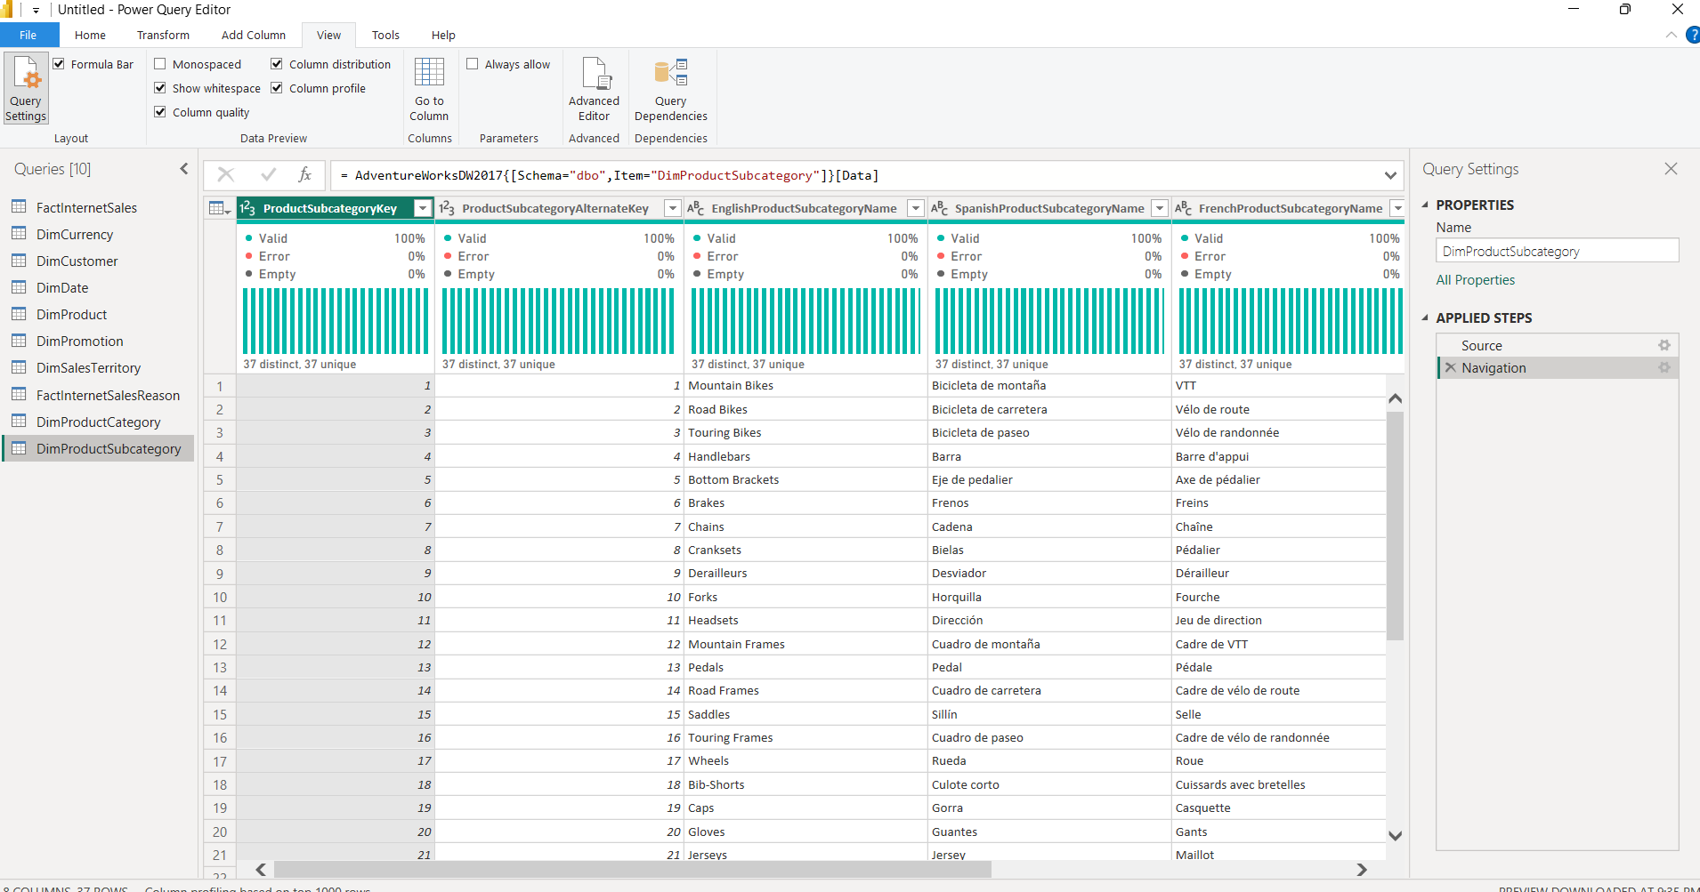

4.5 PIVOT COLUMN
Description:
I created an Order Year column in the FactInternetSales table using the Date.Year([OrderDate]) custom formula.
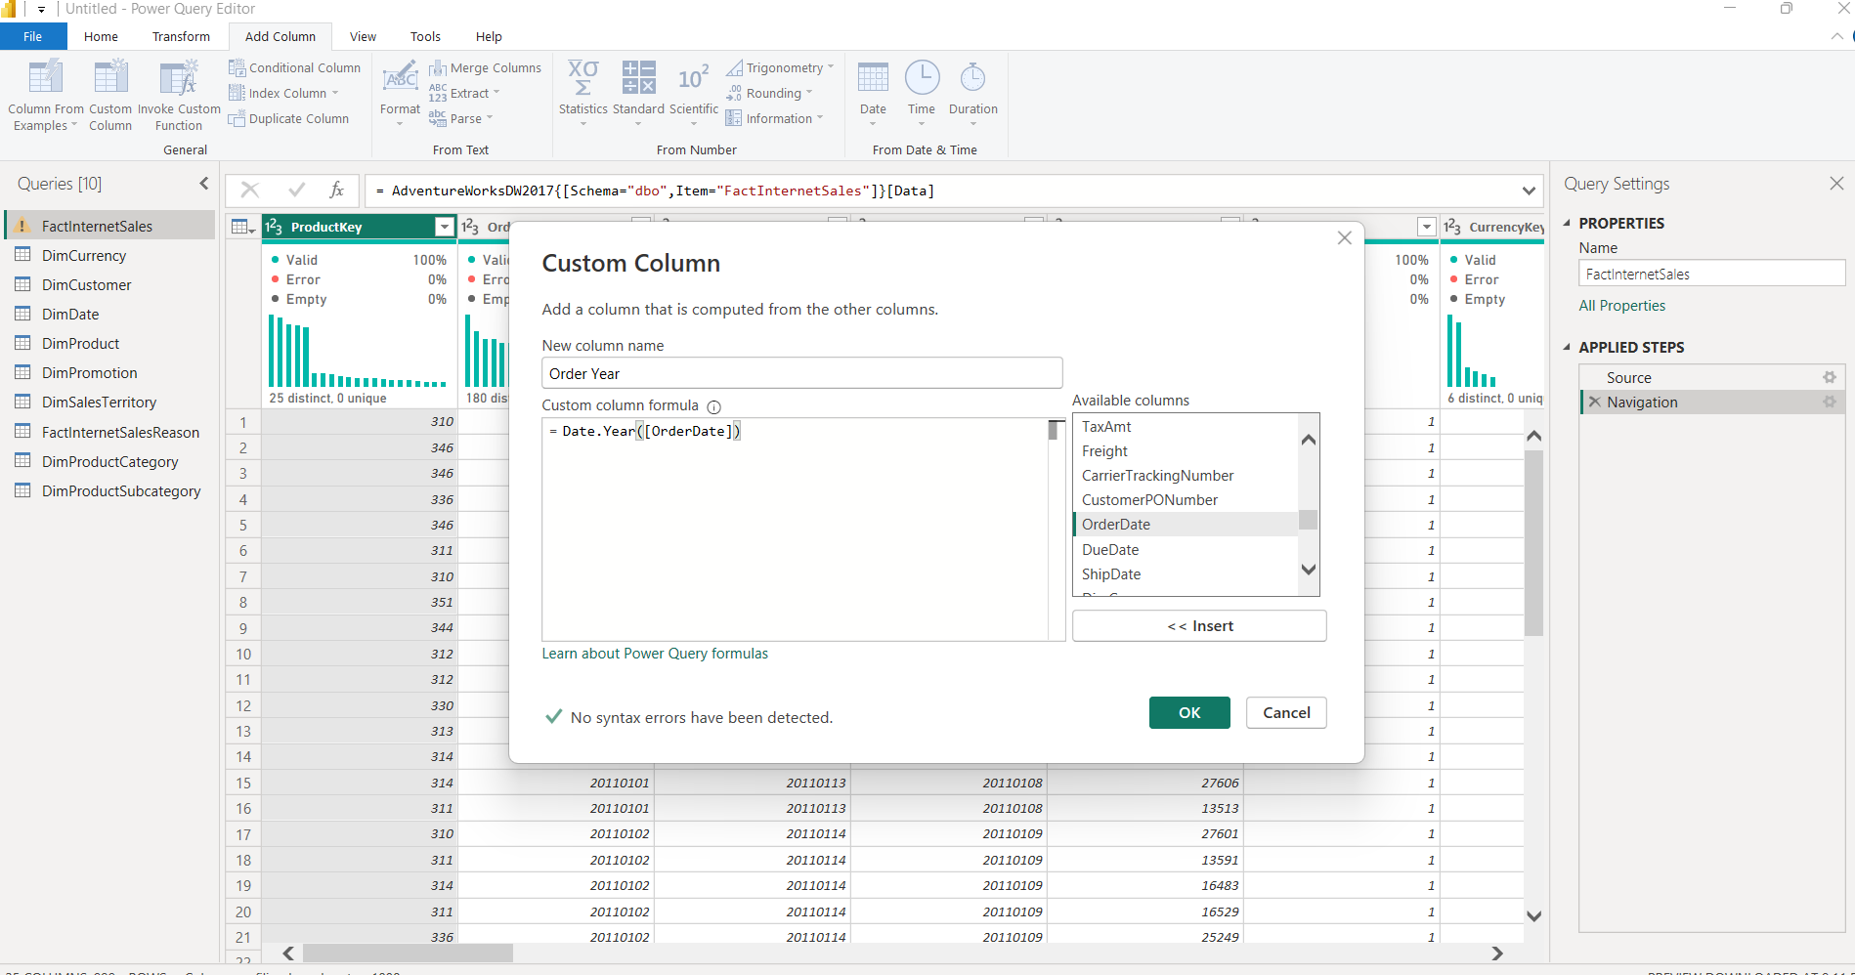

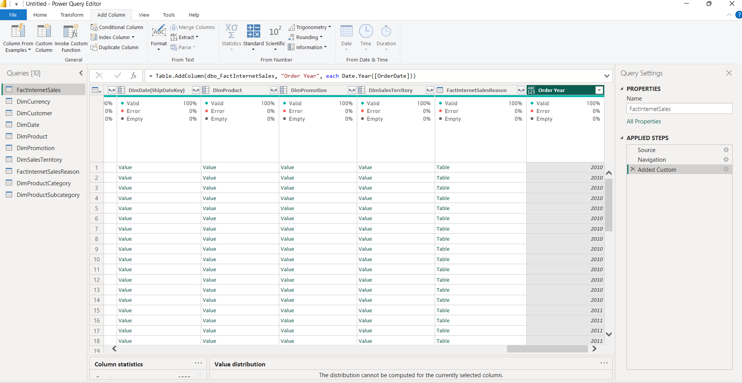

I then created a referenced table named SalesByYearsNPrice, keeping only the columns: 'Order Year', 'OrderQuantity', 'DiscountAmount', and 'SalesAmount'.
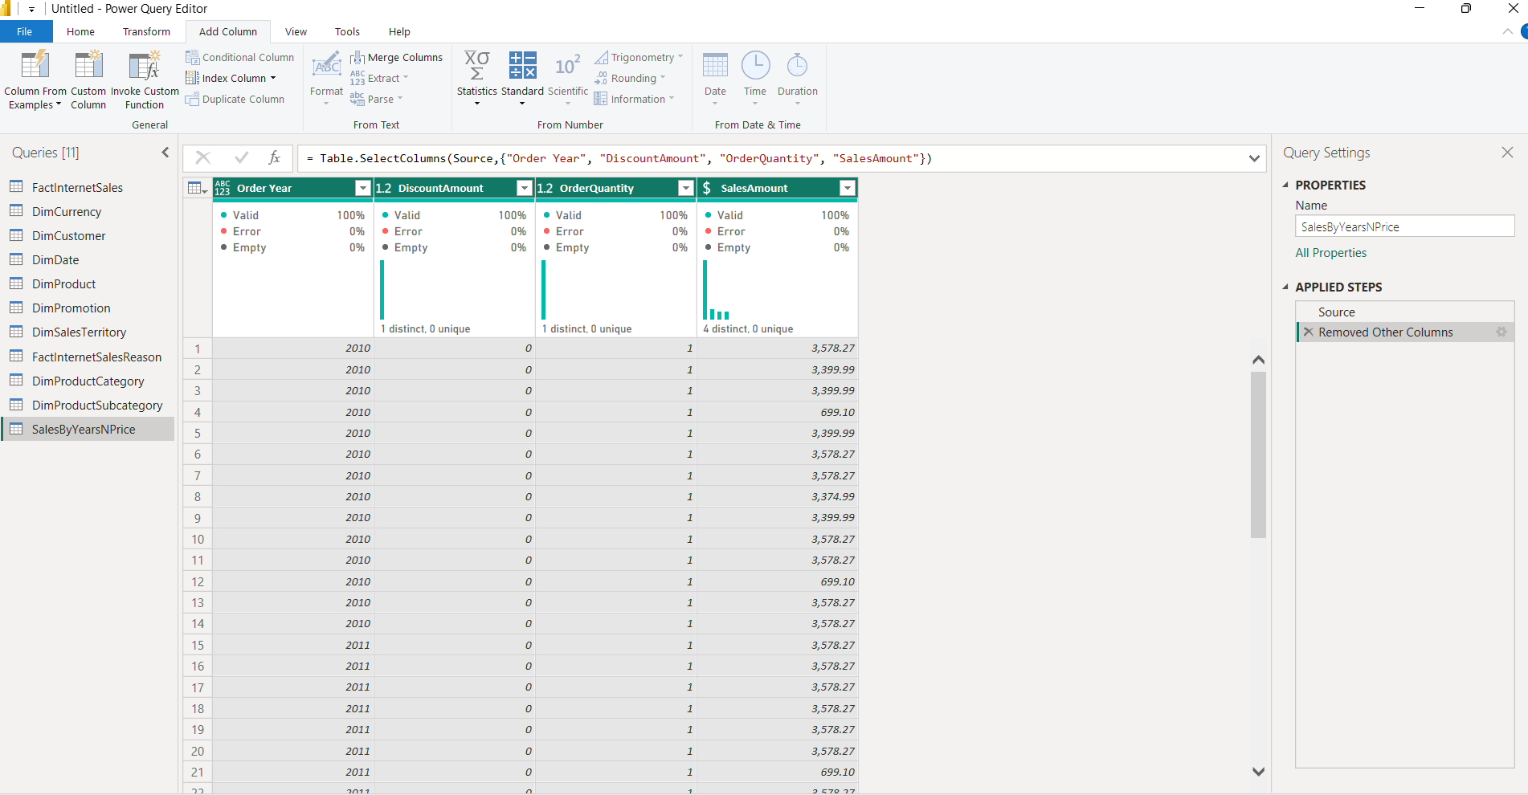

Finally, I applied the Pivot Column transformation on 'Order Year' using 'SalesAmount' as values to see total sales distributed across years as columns.
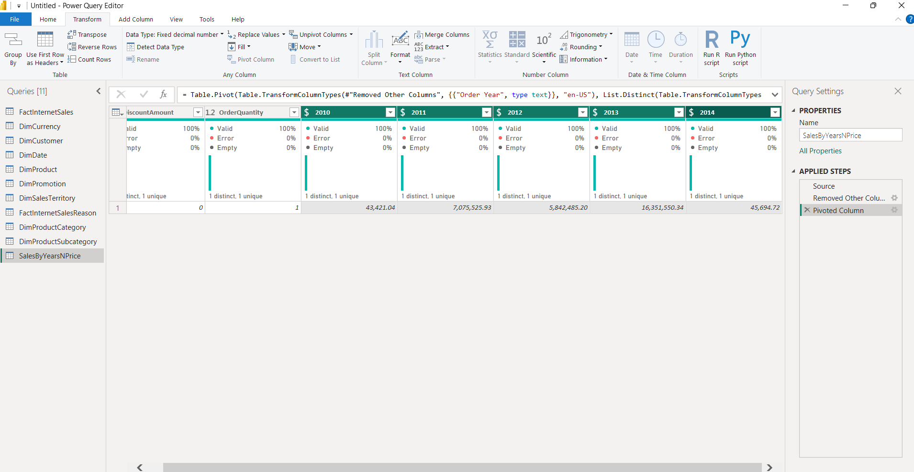

4.6 TABLE JOINING
Description:
I created a new table SalesByCountry (referenced from FactInternetSales). To enrich this table, I performed a Left Outer Join with DimSalesTerritory to bring in the Sales territoryCountry column.
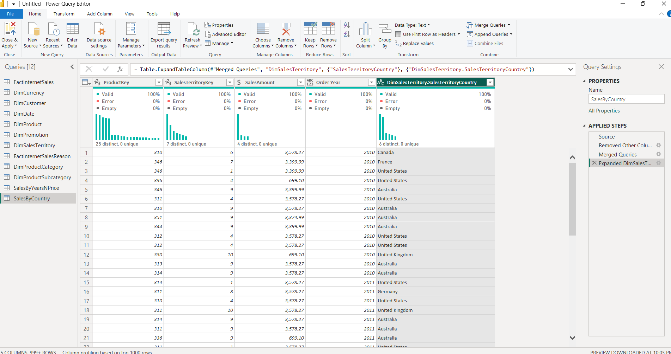

Since categories are not directly linked to sales, I performed a multi-stage join:
Joined with DimProduct to get the subcategory key.
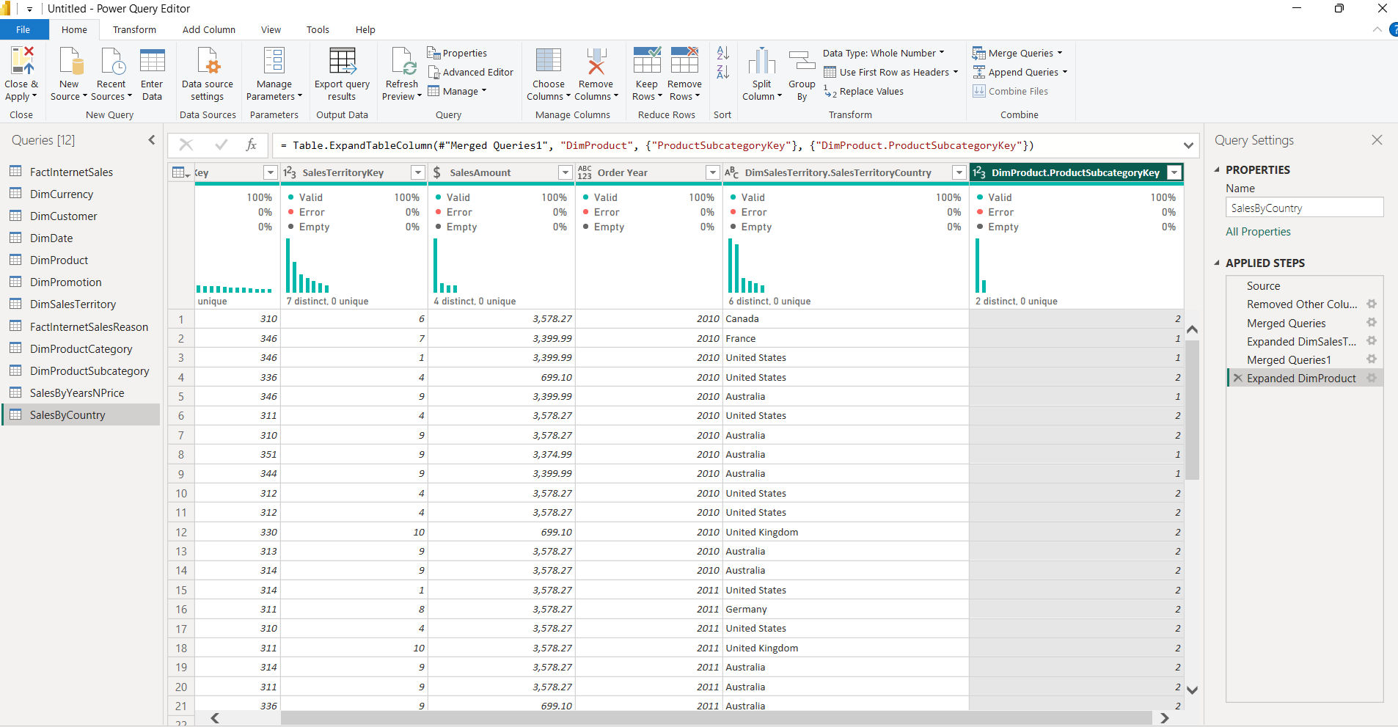

Joined with DimProductSubcategory to get the category key.
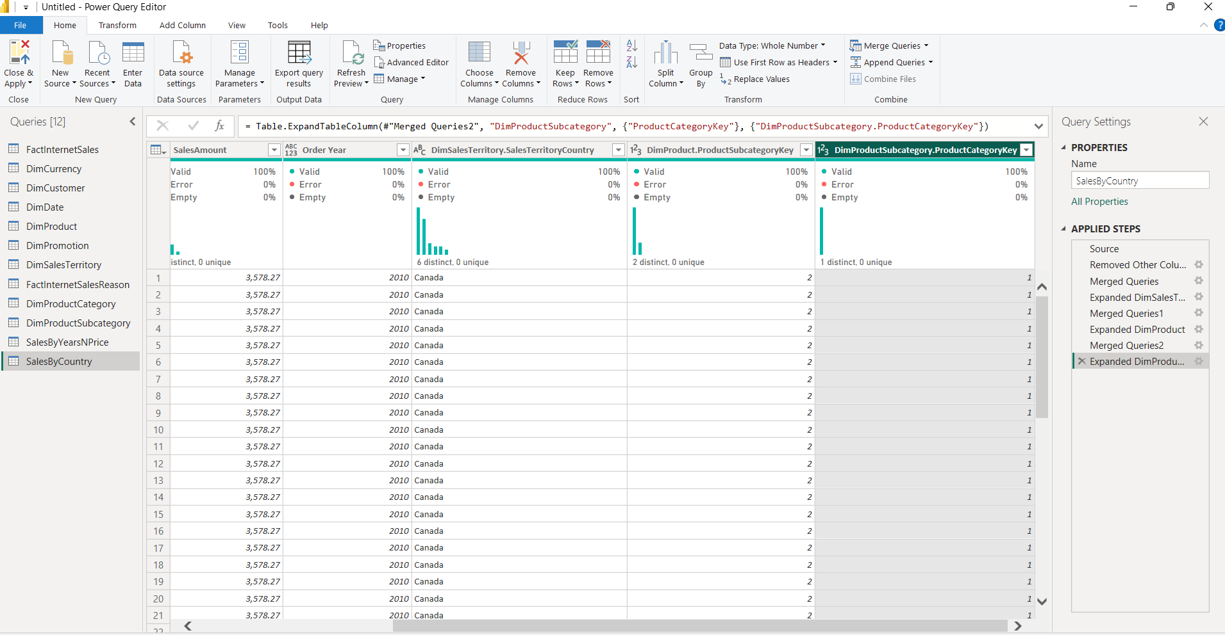

Joined with DimProductCategory to retrieve the EnglishProductCategory name.
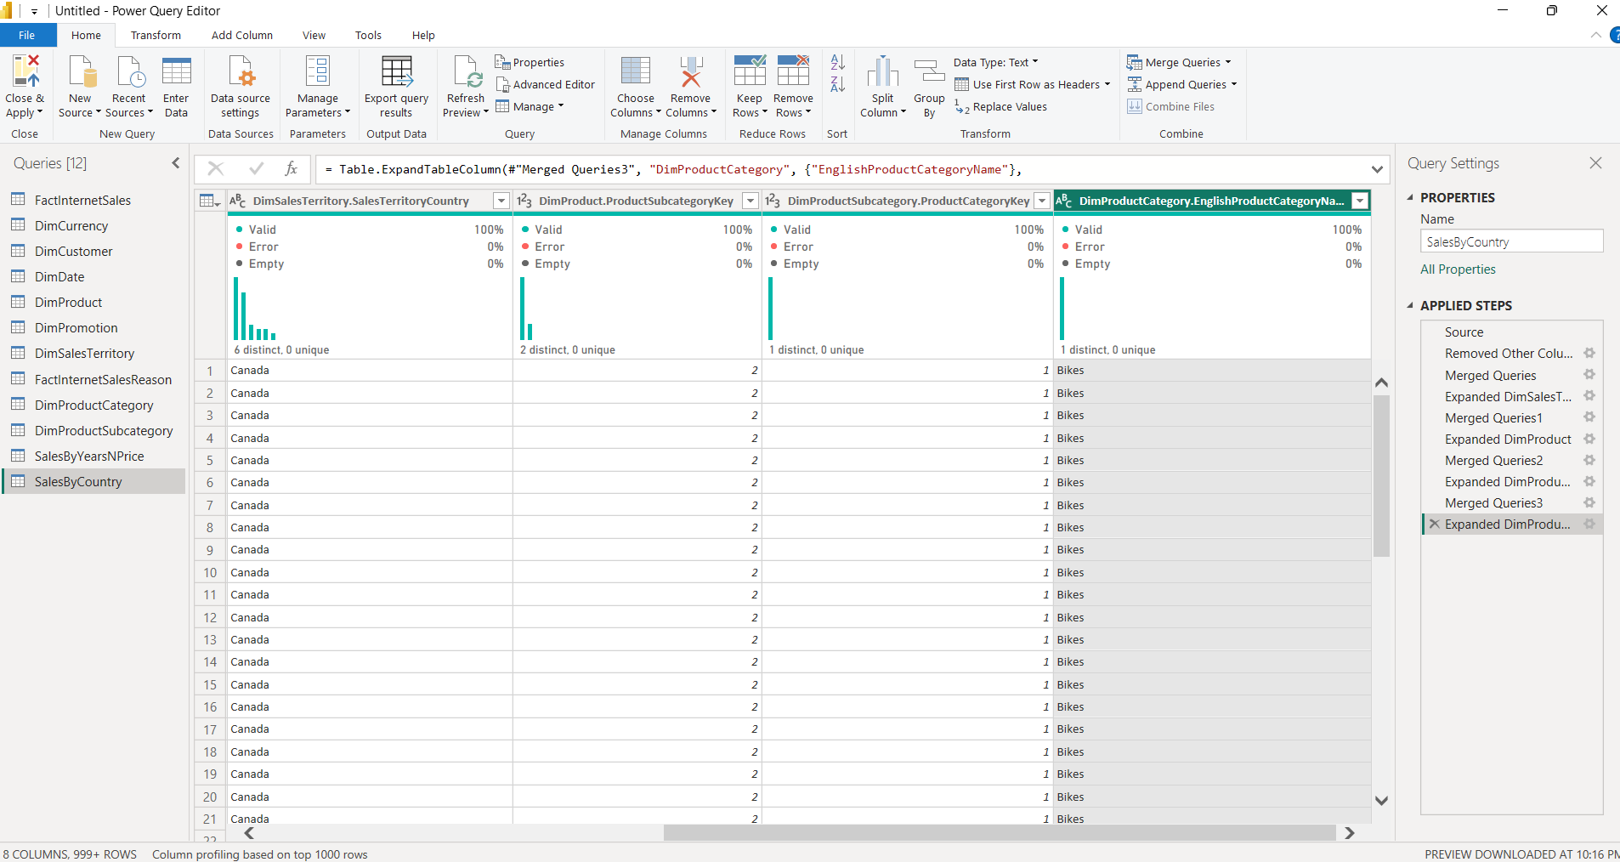

4.7 GROUPING DATA
Description:
Using the Advanced Group By feature, I aggregated the data. I set 'Order Year', 'SalesTerritoryCountry', and 'EnglishProductCategoryName' as grouping levels. I created a new aggregate column 'Sales' using the Sum operation on 'SalesAmount'. The table was then sorted by 'Order Year'.
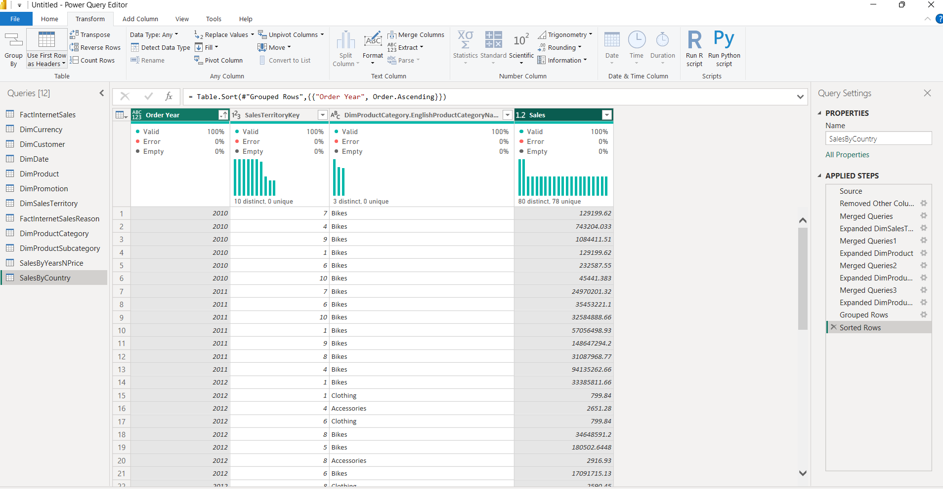

4.9 IMPORT VS DIRECT QUERY
Description:
I created a separate file using the DirectQuery connection mode to compare it with the Import mode.
Key Differences:
1.Import mode proved to be the most flexible tool. It allowed for complex transformations in Power Query (merging tables from different sources, grouping, and creating calculated columns). Its main advantage is the high speed of visualizations due to the use of RAM, but this requires periodic data refreshes.
2. DirectQuery mode works differently: the data isn't loaded into Power BI, but remains in the AdventureWorks database. This ensures a live connection to the server (the data in the report is always up-to-date), but it imposes limitations on some transformation functions and can be slower for complex queries.

4.10 WORKING WITH POWER BI MODEL
Description:
I examined the relationships automatically detected by Power BI. I specifically looked at:
Cardinality: Verified the "Many-to-One" (*:1) relationship between the fact table and dimensions.
Cross Filter Direction: Ensured the direction is set to "Single" (from Dimension to Fact table).

Date Relationship Optimization:
The FactInternetSales table originally had multiple relationships with DimDate (based on OrderDate, DueDate, and ShipDate).
To ensure the analysis focuses strictly on the transaction date, I removed the relationships linked to DueDateKey and ShipDateKey.
I then set the relationship between OrderDateKey (FactInternetSales) and DateKey (DimDate) to Active, which is indicated by the solid line.
